Others things to discuss

There was some changes in server architecture layout which was not properly reflected in documentation:

Recommendation: Please add a diagram with the servers involved in the replication and collectively we will keep this updated

WHITE SR Installation Steps:

1. scripts. – BCCSS DBA

* drop_articles.sql
* drop_subscription.sql
* drop publication.sql
* set_publication database to normal.sql
* set_publication database to replication status
* create publication.sql
* Publisher_9.sql (Application team script required for each release)
* Publisher_11.sql

1. When running the above scripts, it has to be customized based on the replication for different HA databases. The following information is needed:

* Publication Server
* Publication Database
* Publication Name
* Distribution Server
* Distribution Database
* Location of snapshot files
* Snap-shot Agent Account (for Publication & Distribution servers)
* Password for Snap-shot account
* Log-Reader Agent Account (for Publication & Distribution servers)
* Password for Log-Reader Account
* Distribution Agent Account (for Distribution & Subscription servers)
* Password for Distribution Account
* Subscription Server
* Subscription Database

The attached spreadsheet document the setting for both test and production environments of VCH, PHC, FHA, PHSA, BCCSS, BCEHS currently.

The replication setting of NHA, VIHA, IHA are supported by the DBA of the corresponding Health Authority.

1. Stop WHITE application in IIS – PHSA ( 1 min)
2. Stop WHITE Windows service – PHSA ( 1 min)
3. In replication Monitor, in “Agents” tab, stop “Log Reader Agent” - BCCSS DBA per HA (Summary time range) ( 10 minutes)

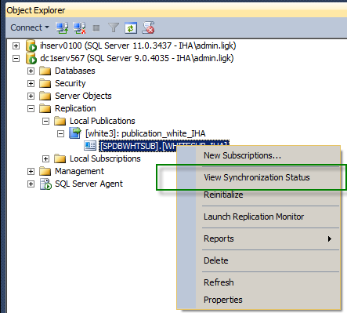

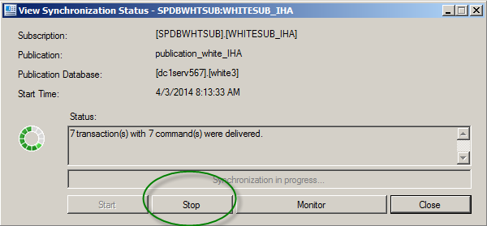

1. Execute “drop_sbuscription.sql” script in publishing db. – BCCSS DBA (15 minutes)
2. Execute “drop_articles.sql” script in publishing db. – BCCSS DBA (10 minutes)   
   need to drop publication and set publication database if the publication database need to be refreshed (15 minutes)
3. (PROD Release) Backup white3 database – (For Test Release) Backup production and restore on test database) BCCSS DBA (2 hour or more, which depends on the size of the source database and the network traffic).
4. Notify WHITE team the database backup is complete – BCCSS DBA
5. Back up WHITE application folder – PHSA ( 1 min)
6. Apply WHITE service pack – PHSA ( 1 min)
7. Start WHITE Windows service – PHSA ( 1 min)
8. Start WHITE application in IIS – PHSA ( 1 min)
9. Notify IHA the completion of service pack installation – PHSA ( 1 min)
10. Execute “Publisher_9.sql” script in publishing db. – BCCSS DBA (10 minutes)  
    if the publication database is refreshed, it needs to set the publication database to replication mode and re-create the publication before running “Publisher_9.sql” (15 minutes)
11. Recreate a snapshot (restart snapshot agent in replication monitor) – BCCSS DBA (20 minutes. It depends on the size of the corresponding publication. It may be longer )
12. Execute “Publisher_11” in publishing db. – BCCSS DBA (10 minutes)
13. Restart log reader agent in replication monitor – BCCSS DBA (5 minutes)